# Abstract

The aims of this investigation was to find (by experiment) the Inductance of an Inductor in an AC circuit (found to be (0.3278x10-3) H), The Capacitance of a capacitor in an AC circuit (found to be () ) and The Resonant Frequency (found to be (740.5) Hz) of an LRC circuit.

# Underlying Physics:

Electromagnetism:

When a current flows through a wire, a magnetic field is induced perpendicular to the wire. By wrapping the wire into a coil and running current through it you can induce a magnetic field creating an electromagnet. The strength of the current determines the strength of the electromagnet. We can increase the strength by increasing the loops in the coil and by wrapping the coil around an iron core.

Faraday’s Law:

When a magnetic field changes by getting stronger; weaker; rotating or moving relative to a coil of wire, a voltage (Emf (Electromotive Force)) is induced in the coil. Faraday’s law describes the relationship between the electromotive f, the rate of change of the magnetic flux (total magnetic field in a given area) () and the number of turns/wraps in the coil:

(Hyperphysics, n.d.)

Where:

Emf is the generated electromotive force (V)

is the number of loops in the coil (No units)

is the rate of change of the magnetic flux (the change of the magnetic field over the change of time) (Tm2s-1)

is the magnetic field (the one changing) (T)

is the area of the coil (m2)

Lenz’s Law:

When an emf is produced due to a changing magnetic flux it also produces a current. This current generates a magnetic field as it flows through a coil of wire as it is becomes an electromagnet. This magnetic field will oppose the change in the magnetic flux that produced the emf and current. This means the induced magnetic field will always ‘try’ to keep the magnetic flux constant. This is known as Lenz’s Law.

Alternating Current:

An alternating current (AC) is one that is constantly changing polarity (direction), when the current is plotted over time the current forms a sine wave, meaning it has frequency and amplitude like any other wave. The effect of AC is to have a lower average current and voltage, referred to as the rms current and rms voltage, and that the current is constantly changing.

The voltage and current of AC at any point in time can be calculated using:

Where:

is the current voltage (V)

is the current voltage (A)

is the maximum voltage (V)

is the maximum voltage (A)

is the angular frequency of the Alternating Current (rads-1)

is the time (s)

Phase:

In an AC circuit both the current and voltage have their own sine wave, phase difference is the difference between the peaks of these to waves, for example some components cause the voltage to ‘lag’ a small amount meaning the peaks of each wave do not occur at the same time. The phase difference is the time difference between the peaks divided by the period of the waves and is measured in degrees. The phase difference is always less than or equal to 90 degrees and refers to the angle by which the voltage leas the current (if the current lags the voltage the phase difference is positive, if the voltage lags the current the phase difference is negative).

Inductors:

An inductor is a coil of wire that opposes the change of current flowing through it, a perfect inductor has no resistance. This occurs as the current flowing through the coil produces a magnetic field. When the current changes so does this magnetic field, and the change in this magnetic field induces an emf, in the opposite direction to the change in current, this is known as back emf.

Where:

is the back emf (V)

is the inductance (H)

is the rate of change of the current (As-1)

A 1H inductor is one that gives 1V of back emf when there is a rate of change in the current of 1As-1. Note: When there is no change in current, there is no back emf produced.

Inductors in AC circuits:

In a sinusoidal AC circuit, the current is constantly changing, this means an inductor will constantly be producing a back emf. The back emf is dependent on the frequency of the AC circuit, this effect is known as inductive reactance. The inductive reactance is equal to the maximum voltage over the minimum current:

Where:

is the inductive reactance ()

is the maximum voltage (V)

is the maximum current (A)

But the inductive reactance is dependent on the frequency of the current, the equation to find the inductive reactance using frequency can be derived as so:

At

∴

Where:

is the voltage of the AC input (V)

is the maximum voltage (V)

is the maximum current (A)

is the angular frequency of the Alternating Current (rads-1)

is the current point in time (s)

is the back current (emf) (V)

is the inductance (H)

is the rate of change of the current (As-1)

is the frequency of the supply (Hz)

is the inductive reactance ()

In an AC circuit an inductor makes the current lag the voltage producing a phase difference of 90o.

Capacitors:

A capacitor is a pair of parallel plates with an insulator between them. A capacitor can be used to store charge. The maximum charge that can be stored on a capacitor is directly proportional to the voltage across it:

Where:

is the charge the capacitor can store (C)

is the capacitance of the capacitor (F)

is the voltage across the capacitor (V)

Charge can flow onto but not through a capacitor (as the plates are insulated from each other). As charge builds up on one plate, it repels charge from the other creating an effective flow of charge. Initially little energy is required to add charge to a capacitor but as the charge stored on the capacitor builds, more energy is required to add more charge and so the rate at which charge is added decreases as charge is added. When the energy required to add more charge is greater than the energy each charge has (the supply voltage) no more charge can be added and so the current stops. At that point, the voltage across the capacitor will be equal to the supply voltage. This process looks like:

Charging:

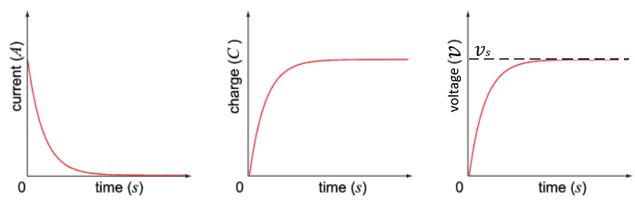

At this point, one of the plates is saturated with charges and the other is deficient. This means when discharging the capacitor the charges will flow from the saturated plate to the deficient one. This is in the opposite direction to the current that originally charged the capacitor. The current starts at its maximum value and decreases to 0A as the charges leave the saturated plate, the rate at which the charges leave the saturated plate decreases as the charge is lost. The voltage also starts at it’s maximum value and decreases to 0V as the charge difference between the two plates decreases. This process looks like:

Discharging:

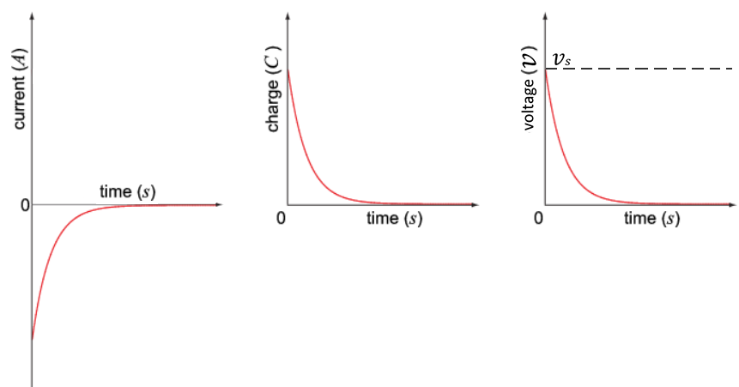

When a capacitor is discharging through resistor the voltage over the capacitor and the voltage over the resistor add to 0, using this fact we can find an equation to find the voltage across the capacitor at any point in time:

Integrate both sides:

At t=0, So and therefore

Where:

is the voltage across the capacitor (V)

is the voltage across the resistor (V)

is the initial voltage (V)

is the current (A)

is the resistance of the resistor (Ω)

is the rate of change of charge ( is charge (C)) (Cs-1)

is the capacitance of the capacitor (F)

is time (s)

This equation shows us that that the voltage across a capacitor decays exponentially.

The same is true for the current and charge, the equations are also similar:

Where:

is the current (A)

is the initial current (A)

is the charge (C)

is the initial charge (C)

The same can be done for when a capacitor is charging through a resistor, in that case the equations are:

The equation for current doesn’t change as the current is still decreasing exponentially

The equations for charge and voltage invert as they are increasing at an exponentially decreasing rate:

is known as the time constant of the circuit and is represented with the symbol

Capacitors in AC circuits:

In a sinusoidal AC circuit, the current is constantly changing, this means a capacitor will constantly be charging and discharging. As while the capacitor charges/discharges it causes the current to decrease this has the effect of opposing the change in current. The opposition to the change in current is dependent on the frequency of the AC circuit, this effect is known as capacitive reactance. The capacitive reactance is equal to the maximum voltage over the minimum current:

Where:

is the inductive reactance ()

is the maximum voltage (V)

is the maximum current (A)

But the capacitive reactance is dependent on the frequency of the current, the equation to find the capacitive reactance using frequency can be derived as so:

At

∴

Where:

is the current voltage(V)

is the maximum voltage (V)

is the angular frequency of the Alternating Current (rads-1)

is the current point in time (s)

is the charge the capacitor can store (C)

is the capacitance of the capacitor (F)

is the voltage across the capacitor (V)

is the current (A)

is the maximum current (A)

is the frequency of the AC supply (Hz)

is the capacitive reactance (Ω)

In an AC circuit a capacitor makes the current lead the voltage producing a phase difference of -90o.

RLC series circuits:

An RLC circuit is a circuit consisting of a resistor, inductor and capacitor in series. When an RLC circuit is ‘hooked up to’ an AC supply the RLC circuit will limit the flow of current:

The reactances subtract as they have a phase difference of 180o, as capacitors make the current lead the voltage by 900 and inductors make the current lag the voltage by 900. This means the peaks and troughs of the current waves created match up.

Where:

is the current (A)

is the voltage (V)

is the resistance of the resister (Ω)

is the inductive reactance of the inductor (Ω)

is the capacitive reactance of the capacitor (Ω)

As the inductive and capacitive reactance are both dependant on the frequency of the supply, the current is also dependant on the frequency of the supply. As (is directly proportional to the frequency) and ( is inversely proportional to the frequency), for a certain frequency will equal and they will cancel out. This results in the current only being limited by the resistor. The frequency at which this occurs is known as the resonant frequency and can be calculated using the inductance of the inductor and the capacitance of the capacitor:

Where

is the angular frequency of the Alternating Current (rads-1)

is the inductance of the inductor (H)

is the capacitance of the capacitor (F)

is the frequency of the supply (Hz)

# Procedures

Experiment 1 – Inductor in an AC circuit:

Apparatus:

* A signal generator 4.5kHz to 1.5kHz (not digital)
* A digital oscilloscope
* A voltmeter (multimeter)
* An ammeter (second multimeter)
* A 0.5H Inductor

Method:

Setup:

The inductor and ammeter were set up in series with the signal generator as the supply.

The voltmeter was then set up in parallel to the signal generator to measure the supply voltage.

The oscilloscope was also set up in parallel to the signal generator to double check the frequency of the supply.

Circuit Diagram:

AC supply

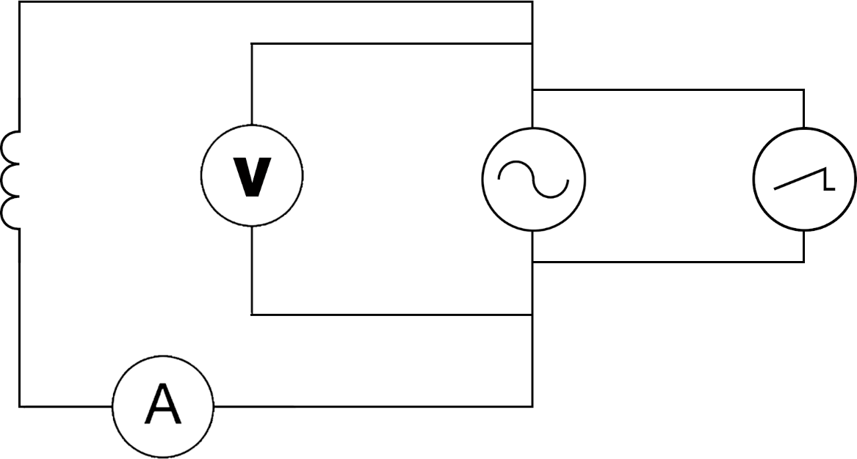

Inductor

Ammeter

Voltmeter

Oscilloscope

Procedure:

The signal generator was set to a frequency which is checked using the oscilloscope, the voltage was adjusted to be 5V, double checking using the voltmeter, and the current was measured using the ammeter, then the signal generator was switched off and on again to get a repeat reading. The frequency was then lowered by 0.5kHz and repeat. The range of frequencies measured were from 4.5kHz to 1.5kHz.

Experiment 2 – Capacitor in an AC circuit:

Apparatus:

* A digital signal generator 1kHz to 100Hz
* A digital oscilloscope
* A voltmeter (multimeter)
* An ammeter (second multimeter)
* A 10 Dielectric Capacitor

Method:

Setup:

The capacitor and ammeter were set up in series with the signal generator as the supply.

The voltmeter was then set up in parallel to the signal generator to measure the supply voltage.

The oscilloscope was also set up in parallel to the signal generator to double check the frequency of the supply.

Circuit Diagram:

AC supply

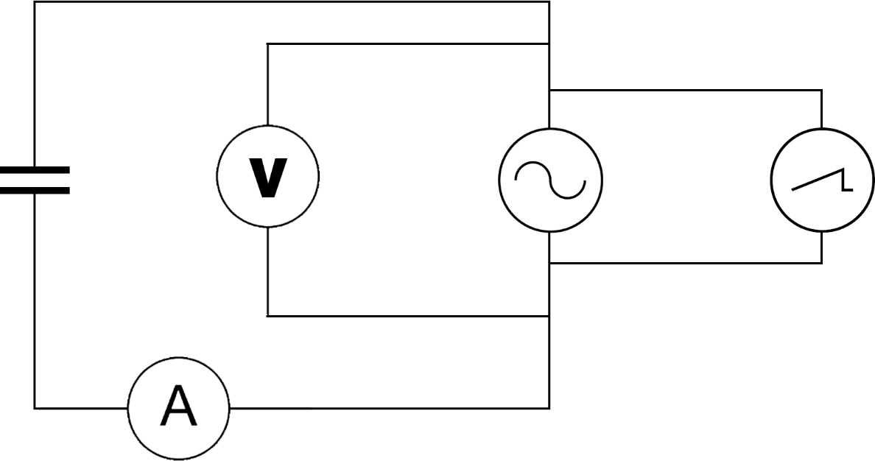

Capacitor

Ammeter

Voltmeter

Oscilloscope

Procedure:

The signal generator was set to a frequency which is checked using the oscilloscope, the voltage was adjusted to be 5V, double checking using the voltmeter, and the current was measured using the ammeter, then the signal generator was switched off and on again to get a repeat reading. The frequency was then lowered by 100Hz and repeat. The range of frequencies measured were from 1kHz to 100Hz.

Experiment 3 – AC current in an RLC circuit:

Apparatus:

* A digital signal generator 10Hz to 130Hz
* A digital oscilloscope
* A voltmeter (multimeter)
* An ammeter (second multimeter)
* A 10 Dielectric Capacitor
* A 0.5H Inductor
* A 100Ω Resistor

Method:

Setup:

The resistor, capacitor, inductor and ammeter were set up in series with the signal generator as the supply.

The voltmeter was then set up in parallel to the signal generator to measure the supply voltage.

The oscilloscope was also set up in parallel to the signal generator to double check the frequency of the supply.

Circuit Diagram:

Capacitor

AC supply

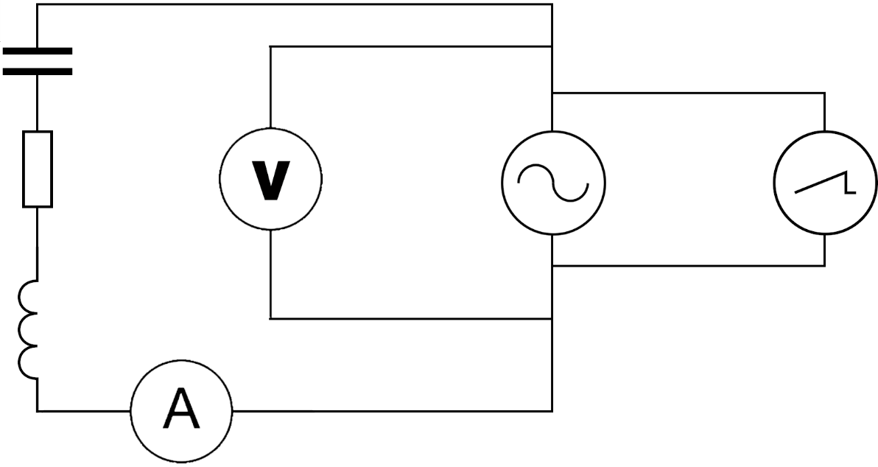

Inductor

Ammeter

Resistor

Voltmeter

Oscilloscope

Procedure:

The signal generator was set to a frequency which is checked using the oscilloscope, the voltage was adjusted to be 5V, double checking using the voltmeter, and the current was measured using the ammeter, then the signal generator was switched off and on again to get a repeat reading. The frequency was then increased by 10Hz and repeat. The range of frequencies measured were from 10Hz to 130Hz.

# Results

Experiment 1 – Inductor in an AC circuit:

Results:

|  |  |  |  |  |  |  |  |  |  |  |  |  |
| --- | --- | --- | --- | --- | --- | --- | --- | --- | --- | --- | --- | --- |
|  | | |  |  | | Current (mA) | |  | |  | |  |
| Frequency (kHz) | | 1/F (s) | Voltage (V) | | 1 | 2 | 3 | 4 | | 5 | | avg |  | |
| 4.5 | | 0.0002222 | 5 | | 0.442 | 0.444 | 0.444 | 0.445 | | 0.445 | | 0.444 |  | |
| 4 | | 0.00025 | 5 | | 0.527 | 0.526 | 0.525 | 0.525 | | 0.525 | | 0.5256 |  | |
| 3.5 | | 0.0002857 | 5 | | 0.623 | 0.622 | 0.622 | 0.622 | | 0.622 | | 0.6222 |  | |
| 3 | | 0.0003333 | 5 | | 0.752 | 0.749 | 0.75 | 0.749 | | 0.749 | | 0.7498 |  | |
| 2.5 | | 0.0004 | 5 | | 0.921 | 0.918 | 0.917 | 0.916 | | 0.917 | | 0.9178 |  | |
| 2 | | 0.0005 | 5 | | 1.152 | 1.151 | 1.15 | 1.15 | | 1.15 | | 1.1506 |  | |
| 1.5 | | 0.0006667 | 5 | | 1.531 | 1.529 | 1.53 | 1.527 | | 1.529 | | 1.5292 |  | |

Uncertainties:

Current uncertainties (mA):

|  |  |  |  |  |  |
| --- | --- | --- | --- | --- | --- |
| averages | Δcal | Δread | Δrand | Δtotal | Δ% |
| 0.444 | 0.0222 | 0.001 | 0.0006 | 0.022231 | ≈5 |
| 0.5256 | 0.02628 | 0.001 | 0.0004 | 0.026302 | ≈5 |
| 0.6222 | 0.03111 | 0.001 | 0.0002 | 0.031127 | ≈5 |
| 0.7498 | 0.03749 | 0.001 | 0.0006 | 0.037508 | ≈5 |
| 0.9178 | 0.04589 | 0.001 | 0.001 | 0.045912 | ≈5 |
| 1.1506 | 0.05753 | 0.001 | 0.0004 | 0.05754 | ≈5 |
| 1.5292 | 0.07646 | 0.001 | 0.0008 | 0.076471 | ≈5 |

These were calculated using the results gathered:

Δcal: this was 5% of the average, this was found in an instruction manual.

Δread: As the multimeter used to read the current was digital this is the smallest unit the multimeter can read.

Δrand: This was calculated using the results gathered: the greatest reading – the lowest reading / the number of readings.

Δtotal:

Δ%: (Δtotal/the average)*100

Frequency uncertainties (Hz):

Δcal was 1x10-2

Which is so small it’s negligible.

Δread = 0.001

Which is also so small it’s negligible.

Δtotal = N/A

Voltage uncertainties (V):

∆cal = 0.8% + 3 of the least sig figs = 0.07 (0.04 + 0.03)

Δread = 0.01

Δtotal = 0.071

∆% = 1.42%

Graph:

gradient = 2.432703936 As-1

intercept = -7.52532x10-5 A

∆ gradient = 0.044827 As-1

%∆ gradient = 1.842698475 1.84%

These values were obtained using the LINEST function in the excel file results were recorded in.

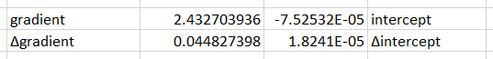

Calculations:

|  |  |
| --- | --- |
| This equation can be put in the form of a straight line formula:  represents , represents  and represents  Using the value of the voltage measured and the value of the gradient from the graph found using the linest function. |  |

Conclusion:

The average inductance of the inductor was (0.3278x10-3) H over a range of 4.5-1.5kHz

Experiment 2 – Capacitor in an AC circuit

Results:

|  |  |  |  |  |  |  |  |  |  |  |  |
| --- | --- | --- | --- | --- | --- | --- | --- | --- | --- | --- | --- |
|  | |  | | Current (A) | |  | |  | |  |  |
| Frequency (Hz) | Voltage (V) | 1 | 2 | | 3 | | 4 | | 5 | avg |
| 1000 | 5 | 0.267 | 0.268 | | 0.268 | | 0.268 | | 0.268 | 0.2678 |
| 900 | 5 | 0.239 | 0.24 | | 0.24 | | 0.239 | | 0.239 | 0.2394 |
| 800 | 5 | 0.212 | 0.213 | | 0.213 | | 0.213 | | 0.212 | 0.2126 |
| 700 | 5 | 0.186 | 0.186 | | 0.186 | | 0.186 | | 0.186 | 0.186 |
| 600 | 5 | 0.159 | 0.159 | | 0.159 | | 0.159 | | 0.159 | 0.159 |
| 500 | 5 | 0.132 | 0.133 | | 0.133 | | 0.133 | | 0.133 | 0.1328 |
| 400 | 5 | 0.106 | 0.106 | | 0.106 | | 0.106 | | 0.106 | 0.106 |
| 300 | 5 | 0.08 | 0.08 | | 0.08 | | 0.08 | | 0.08 | 0.08 |
| 200 | 5 | 0.053 | 0.053 | | 0.053 | | 0.053 | | 0.053 | 0.053 |
| 100 | 5 | 0.027 | 0.027 | | 0.027 | | 0.027 | | 0.027 | 0.027 |

Uncertainties:

Current uncertainties (A):

|  |  |  |  |  |  |
| --- | --- | --- | --- | --- | --- |
| averages | Δcal | Δread | Δrand | Δtotal | Δ% |
| 0.2678 | 0.01339 | 0.001 | 0.0002 | 0.013429 | ≈5 |
| 0.2394 | 0.01197 | 0.001 | 0.0002 | 0.012013 | ≈5 |
| 0.2126 | 0.01063 | 0.001 | 0.0002 | 0.010679 | ≈5 |
| 0.186 | 0.0093 | 0.001 | 0 | 0.009354 | ≈5 |
| 0.159 | 0.00795 | 0.001 | 0 | 0.008013 | ≈5 |
| 0.1328 | 0.00664 | 0.001 | 0.0002 | 0.006718 | ≈5 |
| 0.106 | 0.0053 | 0.001 | 0 | 0.005394 | ≈5 |
| 0.08 | 0.004 | 0.001 | 0 | 0.004123 | ≈5 |
| 0.053 | 0.00265 | 0.001 | 0 | 0.002832 | ≈5 |
| 0.027 | 0.00135 | 0.001 | 0 | 0.00168 | ≈6 |

These were calculated using the results gathered:

Δcal: this was 5% of the average, this was found in an instruction manual.

Δread: As the multimeter used to read the current was digital this is the smallest unit the multimeter can read.

Δrand: This was calculated using the results gathered: the greatest reading – the lowest reading / the number of readings.

Δtotal:

Δ%: (Δtotal/the average)*100

Frequency uncertainties (Hz):

Δcal was 1x10-2

Which is so small it’s negligible.

Δread = 0.001

Which is also so small it’s negligible.

Δtotal = N/A

Voltage uncertainties (V):

∆cal = 0.8% + 3 of the least sig figs = 0.07 (0.04 + 0.03)

Δread = 0.01

Δtotal = 0.071

∆% = 1.42%

Graph:

gradient = 0.00027AHz-1

intercept = -0.000347A

∆ gradient = 7.4E-07As-1

%∆ gradient = 0.278145322 0.28%

These values were obtained using the LINEST function in the excel file results were recorded in.

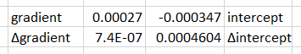

Calculations:

|  |  |
| --- | --- |
| This equation can be put in the form of a straight line formula:  represents , represents  and represents  Using the value of the voltage measured and the value of the gradient from the graph found using the linest function. |  |

Conclusion:

The average inductance of the inductor was ()

Experiment 3 – AC current in an RLC circuit:

Results:

Uncertainties:

Graph:

Calculations:

Conclusion: